**Project 2A – Description and Explanation**

The task was to create an array of Student records for ID, Name, Address, and GPA (1), and then display the record (2), then push the records to a static stack (3), then pop the records off the static stack(4).

1. The task was to push the student information from a file into a set of students array. This was accomplished through reading in the information from a file with a loop. Each field of student information was read into its own separate array:

Screen Shot 2014-05-04 at 5.54.34 PM.png

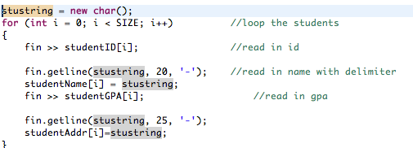

1. The display task was accomplished by looping through the student information in the array and displaying it with the appropriate formatting:

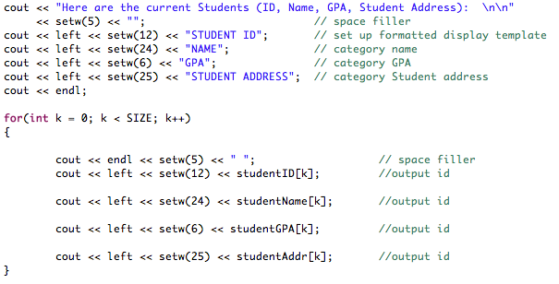

1. The task of pushing the information onta the static stack took place by creating a static stack object and then pushing it into the stack item with the push function. As each item was pushed onto the static stack the top of stack pointer was incremeneted:

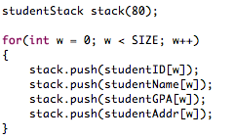

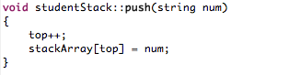

1. The final task was to pop 5 records off the stack and display what remained. This took place through the pop function that caught the variables as they were popped off the static stack:

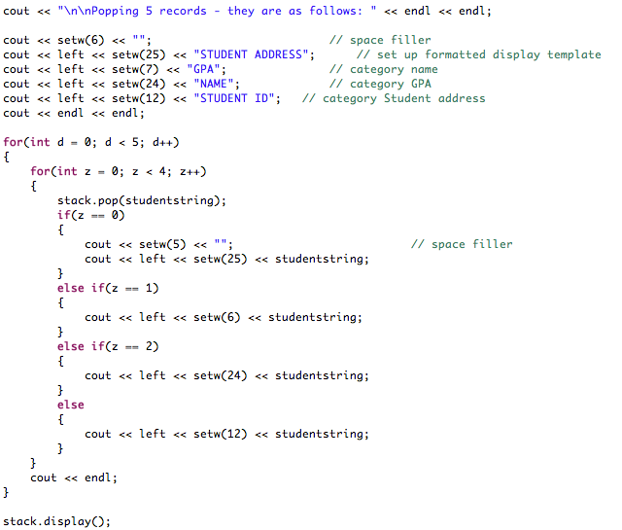

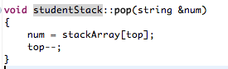

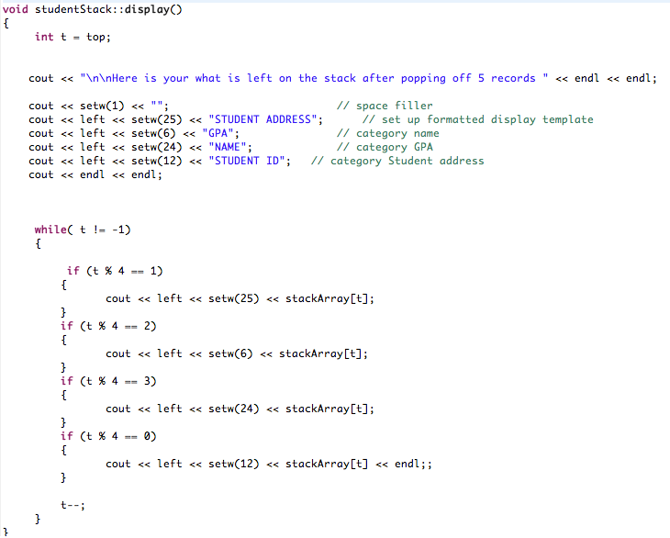

**Project 2 Input and Output**

Here are the current Students (ID, Name, GPA, Student Address):

STUDENT ID NAME GPA STUDENT ADDRESS

33454444 Mike Stiller 3.75 221 Blue St.

69988963 Marcy Eckhert 2.43 953 Ridgeway Rd.

47763329 Lyndon Johnson 3.45 802 Love Ln.

55584739 Wes Thompson 2.24 839 Hollow Tr.

13453329 Alex Cortez 3.53 109 Crest St.

45553894 Ben Lyons 3.34 220 Ridge Rd.

59860454 Jimmy Woods 3.77 234 Orange St.

38889643 Christie Mickey 3.45 552 Nickel Rd.

59988963 Stella Esquire 3.33 9595 Colby Rd.

61111339 Joey Gerald 2.46 1393 Mustang Tr.

23897939 Ash Catchum 3.44 1550 Sagewood Tr.

32498887 Caleb Nesbit 3.33 200 Peach Rd.

66644324 Jackie Wild 2.74 134 Yellow St.

57688874 Ricky Bobby 3.23 1776 Apple Ln.

12493894 Ryan Marsh 3.23 220 River Rd.

71771132 Michael Batson 1.46 1223 Lina Tr.

52347499 Lexi Ryan 2.40 729 Wave Rd.

20829499 Beth Marie 3.03 110 Copper Rd.

44445939 Ashley Amigo 2.36 119 Sage Tr.

75779329 Charlie Kowalski 4.00 919 Prarie Tr.

Popping 5 records - they are as follows:

STUDENT ADDRESS GPA NAME STUDENT ID

919 Prarie Tr. 4.00 Charlie Kowalski 75779329

119 Sage Tr. 2.36 Ashley Amigo 44445939

110 Copper Rd. 3.03 Beth Marie 20829499

729 Wave Rd. 2.40 Lexi Ryan 52347499

1223 Lina Tr. 1.46 Michael Batson 71771132

Here is your what is left on the stack after popping off 5 records

STUDENT ADDRESS GPA NAME STUDENT ID

220 River Rd. 3.23 Ryan Marsh 12493894

1776 Apple Ln. 3.23 Ricky Bobby 57688874

134 Yellow St. 2.74 Jackie Wild 66644324

200 Peach Rd. 3.33 Caleb Nesbit 32498887

1550 Sagewood Tr. 3.44 Ash Catchum 23897939

1393 Mustang Tr. 2.46 Joey Gerald 61111339

9595 Colby Rd. 3.33 Stella Esquire 59988963

552 Nickel Rd. 3.45 Christie Mickey 38889643

234 Orange St. 3.77 Jimmy Woods 59860454

220 Ridge Rd. 3.34 Ben Lyons 45553894

109 Crest St. 3.53 Alex Cortez 13453329

839 Hollow Tr. 2.24 Wes Thompson 55584739

802 Love Ln. 3.45 Lyndon Johnson 47763329

953 Ridgeway Rd. 2.43 Marcy Eckhert 69988963

221 Blue St. 3.75 Mike Stiller 33454444

**Main.cpp**

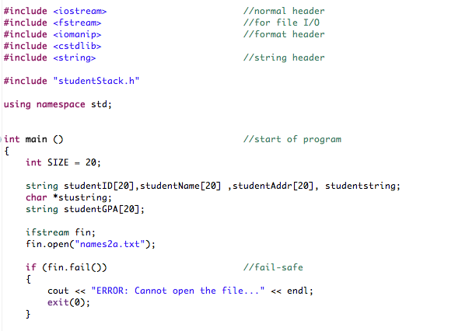

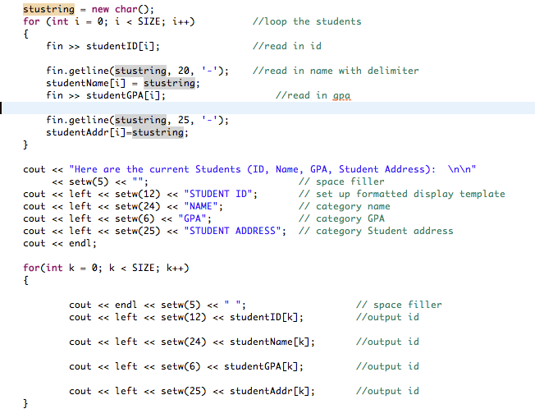

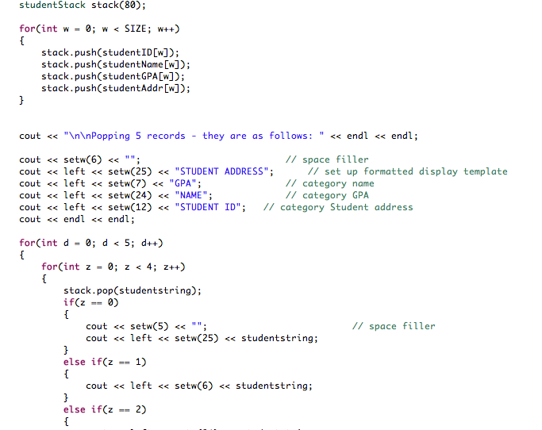

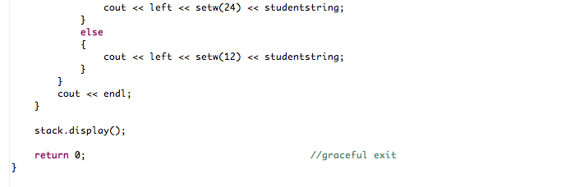

**StudentStack.h**

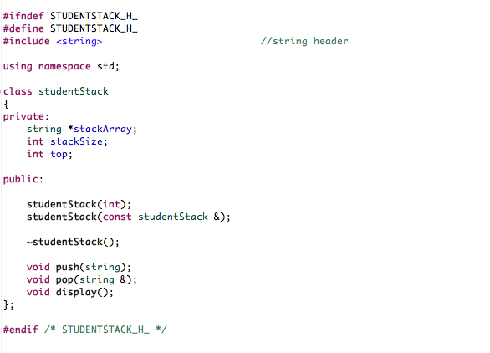

**StudentStack.cpp**

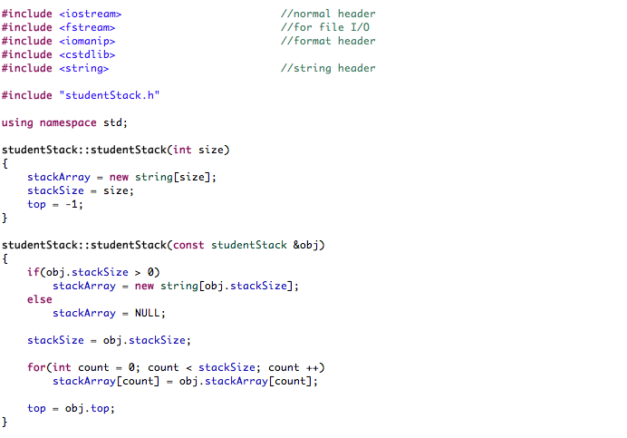

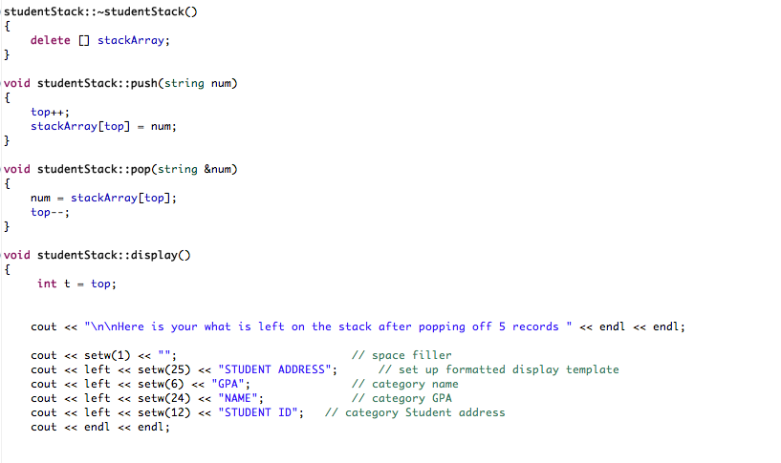

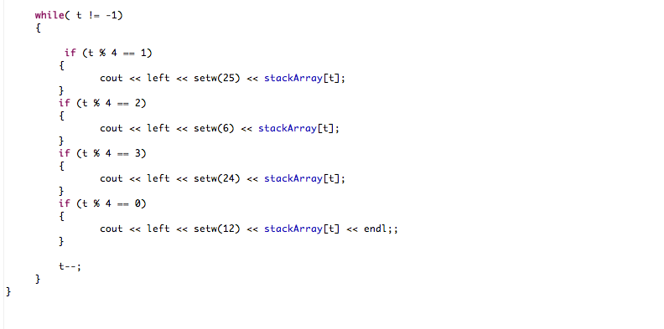

**Names2a.txt**

